**Stage 6 – Fixed the newel post!**

**RULES:** USPSA Competition Rules, Latest Edition **COURSE DESIGNER:** Ike Starnes

|  |  |
| --- | --- |
| **START POSITION: See written stage briefing.** | |
| **STAGE PROCEDURE**  See written stage briefing. | **SCORING**  **SCORING:** Comstock 3 rounds.  **TARGETS:** 3 steel targets  **SCORED HITS:** Steel must fall to score.  **START-STOP:**  Audible - Last shot  **PENALTIES:** Per USPSA Competition Rules |

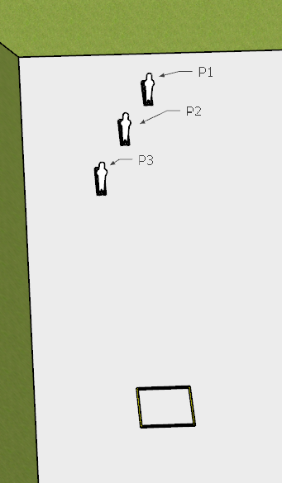

**Written Stage Briefing:**

**Stage 6 –** **Fixed the newel post!** is a 3-round, 15 point, Comstock Multi-string Short Course. There are 3 steel targets. The steel must fall to score

**String 1:**

**Start position** Both feet inside the shooting box.

**Handgun**: Loaded and holstered with wrists below belt.

**PCC**: Loaded, stock on belt.

On the audible start signal, engage **P1** **freestyle** from within the shooting area.

**String 2:**

**Start position** Both feet inside the shooting box.

**Handgun**: Loaded and holstered with wrists above shoulders.

**PCC**: Loaded, stock on belt, strong hand wrist above shoulders.

On the audible start signal, engage **P2** **strong hand / strong shoulder only** from within the shooting area.

**String 2:**

**Start position** Both feet inside the shooting box.

**Handgun**: Loaded and holstered with wrists below belt.

**PCC**: Loaded, stock on belt.

On the audible start signal, engage **P3** **weak hand / weak shoulder** only from within the shooting area.

**Setup Notes:**

3 Mini Poppers

3 Popper Bases

1 3x3 shooting box